Teen Summer
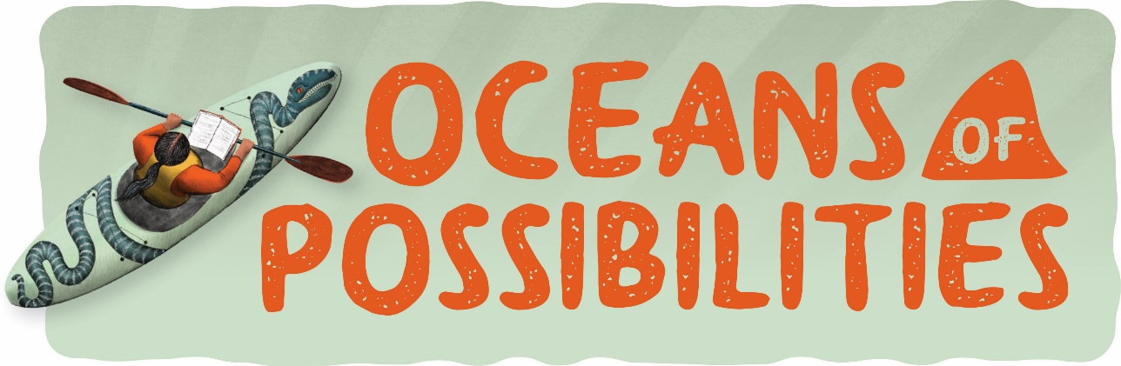
Reading Challenge 2022

The Teen Summer Reading Challenge is open to the ages of 13-17 that have an active library card for the Presque Isle District Library. Registration will open June 1st and forms will
be available at each of our branches.

We will have incentives to reward the teens with the most pages read of the summer! Register at any PIDL Library and fill out a reading slip with your name, title, author and ISBN after every book you read and turn it into your home branch. (Graphic novels count too!) Page numbers will be added up at the end of the program on July 31st and winners will be announced by August 10th.

Check out our Facebook page for Summer Reading Program events.

Children Summer
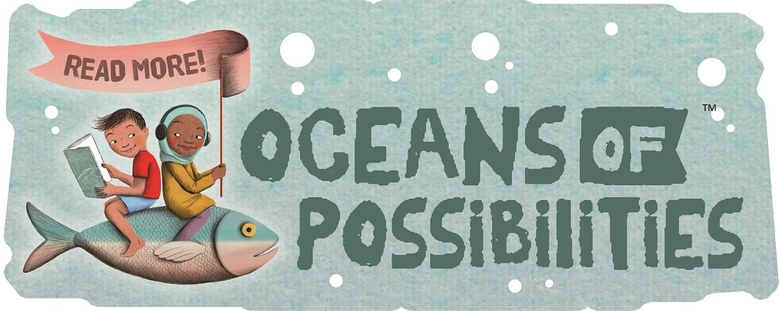
Reading Challenge 2022

The Children Summer Reading Challenge is open to the ages of 3-12
that have an active library card for the Presque Isle District Library. Registration will open June 1st and forms will
be available at each of our branches.

Each child will receive a packet of bubble sheets that they can track their reading with. Every bubble filled in is five minutes and the number of bubbles is tailored to each age group. Once they finish a bubble sheet they can be turned in for an instant reward. If all five bubble sheets are turned in, we have bonus bubble sheets for a free book!

Check out our Facebook page, website or take a Summer Reading Program 2022 brochure for events and storytimes.
